Executive Summary

Vehicle accidents cause significant damage to one’s health, and finances. One factor contributing to such accidents arises from users being unaware of obstacles in their blind spot. As a result, lane changing becomes a dangerous maneuver. To account for this issue, we are prototyping a system that will warn users of obstacles present, or approaching their vehicle’s blind spot, as well as preventing them from making unsafe lane changes.

The design is intended to be used on a scaled down remote controlled vehicle. It consists of three main modules: obstacle detection, output, and automation. The obstacle detection module uses ultrasonic sensors, and a microcontroller to identify obstacles present or approaching the user vehicle’s blind spot. The microcontroller calculates the obstacle’s position, relative speed, and the amount of time required for it to reach the blind spot (if not already present) using the sensor’s distance values, and the trigger rate. This information is then communicated to the output module, which consists of two LED lights providing qualitative feedback (blinking frequency corresponding to safety levels), and an LCD display providing quantitative feedback (microcontroller’s calculated distance, speed and time values). Finally, the automation module allows the microcontroller to assume control of the user vehicle. The purpose of this module is to prevent collisions by locking the steering of the user vehicle towards the obstacle.

In order to validate our design, several test cases are to be utilized for each module. The obstacle detection module must be able to measure distances accurately within the defined blind spot region. In addition, relative velocities must be calculated in order to anticipate obstacles. The LED must blink at frequencies corresponding danger levels, and the LCD must display the microcontroller’s calculated values. These features will be verified by placing obstacles at known distances from the user vehicle, travelling at known relative speeds. The microcontrollers calculated values, in conjunction with the behaviour of the output module will then be compared against these known values. Finally, the automation module will be verified by placing obstacles in situations where the user has less than two seconds to make a lane change, and ensuring the steering of the user vehicle is locked to prevent dangerous lane changes.

The main component of the design is the microcontroller, as it is responsible for integrating all of the modules. The microcontroller will be programmed using C++. Knowledge required to complete the project has mostly been gained through previous experiences and research over the summer period. Further knowledge regarding device operation and vehicle dynamics will be acquired throughout the year. Material resources have already been obtained. The overall cost of the project is expected to be $243.

The main risks associated with the project depend on the operation of the sensors. If the sensors fail to obtain or calculate values accurately due to external factors such as lighting, weather, and unintended obstacles, the operation of the device is at risk. To mitigate these risks, more advanced sensors may be required if the problem cannot be solved with compensational software algorithms. In addition, validating the obstacle anticipation module is risky as keeping both the user vehicle and obstacle at constant relative speed may be difficult.

Table of Contents

Project Description 2

Background and Motivation 2

Project Goal 2

Project Requirements 2

Functional Requirements 2

Constraints 3

Objectives 3

Validation and Acceptance Test 3

Technical Design 4

Possible Solutions and Design Alternatives 4

Assessment of Proposed Design 5

System-Level Overview 7

Module-Level Description 7

Work Plan 9

Work Breakdown Structure (WBS) 9

Financial Plan 9

Feasibility Assessment (Resources, Risks) 10

Skills and Resources 10

Risk Assessment 11

References 12

Appendices 13

Appendix A: Student – Supervisor Agreement form. 13

Appendix B: Draft B Evaluation Form 14

Appendix C: Report Attribution Table 15

Appendix D: Statistics on Collisions and Casualties 16

Appendix E: Quantitative Measures for Technical Requirements 17

Appendix F: Blind Spot Region. 18

Appendix G : Calculations Performed by the Microcontroller 19

Appendix H: Classification of Danger Levels 22

Appendix I: Gantt Chart 23

# Project Description

## Background and Motivation

Vehicle accidents cause physical injuries, mental trauma, financial loss, and in the most extreme cases: death. According to Statistics Canada, in 2009, there were 123,192 total recorded collisions in Canada. 2,011 of these were fatal [1]. In 1990, total number of collisions was 178,515; 3,445 of which were fatal [1]. As further indicated by Canadian accident statistics (Appendix D), the numbers have decreased dramatically. This decrease can be largely credited to advancements in vehicle safety technology, among other factors. Though there is a decrease, as the numbers indicate, accidents are still a significant issue.

It has been found that 95% of accidents are caused by bad driving behavior [2]. One common driving behavior is to not check the vehicle’s blind spot while changing lanes, which leads to accidents during lane changes. To account for this issue, car manufacturers such as BMW [3], Volvo [4], and Ford [5] are introducing vehicle blind spot assist technologies in their new vehicle models. However, not every driver is able or wants to attain these vehicle models. Therefore, there is a need for a universal and affordable device that can aid users in becoming aware of obstacles in their blind spot. Advances to the currently available technology also need to be made to further prevent accidents in general.

## Project Goal

The goal of the project is to aid in accident prevention through a device that will aid users identify and anticipate obstacles in their vehicle’s blind spot. In addition, the device will be able attain vehicle control to prevent the user from steering into obstacles in the blind spot. In order to achieve this, the group will build a prototype to be tested on scaled down vehicles (i.e. remote controlled cars) under simulated road conditions.

## Project Requirements

## Functional Requirements

1. The unit shall have sensors mounted on the sides (near the rear) of the user vehicle, such that it covers the defined blind spot region (Appendix F), and is able to obtain the distance to the obstacle and its position within the blind spot
2. The unit shall have a microcontroller to compute the following based on the inputs:
   1. The relative speed of the obstacle to the user vehicle within ±10% accuracy
   2. The amount of time needed for the approaching obstacle to appear in the blind spot, if not already there

3. The unit shall have a feedback mechanism to warn the user of potential danger based on the microcontroller's calculated relative speed and time allowed for a lane change (Appendix G, Appendix H)

4. The unit shall have an override mechanism that will prevent users from making unsafe lane changes by locking the steering of the user vehicle towards the obstacle under conditions outlined in Appendix H

1. 5. The Unit shall adhere to the required technical parameters (Appendix E)

## Constraints

1. The unit must cost less than $500
2. The unit must weigh less than 1kg
3. The unit must not impede the user’s view of the road
4. The user vehicle must not exceed the maximum length of 12.5 m, and a maximum width of 2.6 m (to be scaled down by the vehicle prototype ratio) with the unit attached [6]

## Objectives

1. The unit’s input sensor shall work correctly regardless of light and weather conditions
2. The blind spot detection component of the unit (no vehicle override) should be a standalone device
3. The microcontroller should be hidden from the user’s view

## Validation and Acceptance Test

The test plan for individual modules of the design is outlined in the following table:

|  |  |  |  |
| --- | --- | --- | --- |
| **Module** | **Requirements** | **Test** | **Acceptance Criteria** |
| **Obstacle detection/anticipation** | Sensors should measure distances accurately | Place obstacles at 4 different distances(3cm, 1m, 2m, 3m) away from the sensors | Computed distances match the measured distances within ±2.5% error |
| Blind spot Coverage | Mount the sensors on the remote controlled (RC) car to cover the defined blind spot (Appendix F); place obstacles within it | The sensors detect the presence of the obstacle within the defined range |
| Microcontroller should compute relative speed based on distance values | Mount sensors to the RC car; place an obstacle and the RC car in motion with a known relative speed | The microcontroller’s calculated speed values match the known value within ±5% error |
| Obstacle Anticipation | Set up situations where both distance and relative speeds are known, and perform allowed time calculations with the microcontroller | The microcontroller’s time values match the calculated ones within ±12% error |
| **Output** | The Light Emitting Diodes (LED) and the display should provide accurate feedback to the user | Observe the feedback response of the LED and the Liquid Crystal Display (LCD) display | The LED should behave according to the defined look-up table (Appendix H); the display should contain calculated values of distance to obstacle; relative speed, and time left for a lane change |
| **Automation** | The steering of the RC car should lock when necessary | Simulate the extremely dangerous, and very unsafe cases (Appendix H) | The steering of the user car is irresponsive in the direction of the obstacle |

Table 1: Validation and Acceptance Tests

# Technical Design

## Possible Solutions and Design Alternatives

Alternatives were considered in the following components of the design:

* Controller/Compute Unit
* Input (Sensors)
* Output
* Automation

The following table outlines the alternatives considered, and compares them by their advantages and disadvantages:

|  |  |  |  |  |
| --- | --- | --- | --- | --- |
| **Component** | **Possible solution** | **Type** | **Advantages** | **Disadvantages** |
| **Micro-Controller** | Arduino Uno |  | Programmed using C/C++;   cheap ($30); easy to use due to its IO pins | Relatively bigger in size than other controllers |
| Picaxe |  | Comes with software that allows flow charts; no programming required; easy to work with | Limited functionality |
| **Input - Obstacle Detection** | SRF05 Ultrasonic Rangefinder |  | Good range (~ 3m) and accuracy (± 2% error), relatively cheap ($40) | Complex programming required; relatively expensive; prone to interference from miscellaneous obstacles |
| LR3 - Precision USB Laser Rangefinder |  | Very high accuracy (+- 3mm) and range (30m) | Expensive ($150); requires external tools, very sensitive to light conditions |
| Sharp IR Rangefinder R48-IR12 |  | Very cheap ($15); immune to ambient light interference; low power consumption | Narrow beam width; prone to other IR sensor interference, low range (10 cm - 80 cm) |
| Camera - image detection |  | Accurate; images can be reproduced for the driver | Complex image processing algorithms required; expensive |
| **Output - Feedback** | Visual | Graphical | Very informative; aesthetically pleasing | Distracting; expensive; may experience scaling issues, resulting in inaccurate and unreliable output |
|  | Numerical | Quantitative; very accurate; informative; | May cause confusion among some users; aesthetically displeasing |
|  | Simple - blinking light | Inexpensive; Easy to implement; very simple, yet informative | No quantitative feedback; small in size |
| Auditory | Beeping sounds | Easy to implement; Inexpensive; simple | Irritating; may be inaudible due to music or ambient sounds |
| Physical | Vibration of the steering wheel | Very effective | Distracting; vehicle dependent |
| **Automation** | Automated Lane Merging System |  | Allows the user to easily and safely change lanes | The automated lane change system may cause the undesirable vehicle speeds; the automated system may not be able to change lanes fast enough for certain cases such as exiting the freeway; impractical during high traffic |
| Steering-Lock |  | Prevents collisions during lane changes | Takes away the user’s judgment factor; may cause a more serious frontal collision |

Table 2: Alternatives Considered

## 

## Assessment of Proposed Design

For our microcontroller, we decided to use the Arduino Uno. The advantages of the Arduino Uno are:

1. I/O are easily accessible through sockets
2. Wide variety of libraries and helpful online community
3. Easily programmable using C/C++

The tradeoff for using the Arduino is that it is bigger in size compared to our alternatives. This is an issue in terms of scaling, as it appears relatively large compared to our user vehicle prototype. In addition, powering the Arduino Uno as a mobile device may also be problematic as it requires further resources.

For our sensors, we have decided to use the SRF05 ultrasonic sensor. The advantages of the SRF05 are:

1. Fast sampling rate (50ms or 20 times/sec).
2. Large detection range (from 3 cm to 4 meters)

The tradeoff for the SRF05 sensor is that it is relatively expensive compared to alternatives such as the IR sensors. The size of SRF05 poses further scaling issues. However, its long range capabilities are essential to the obstacle anticipation feature.

For our output, blinking LED lights, in conjunction with a LCD display was chosen. The LED will blink as the car starts approaching the blind spot. As soon the car is within the blind spot range, the blinking light will turn into a solid light. The LCD display will provide the user with accurate information on relative distance, and speed of the obstacle. In addition it will provide an approximation of the amount of time left to make a lane change. The advantages of this solution are:

1. Two modes of operation of the LED light provide simple, yet informative feedback
2. The LCD display provides the user with quantitative feedback to further help their judgment
3. LED lights/LCD displays are the least costly among the alternatives

The tradeoff for using the LED lights is that it is very minimalistic, and may not appeal to some users. However, to account for this, we have included the LCD display. The LCD display on the other hand is aesthetically displeasing, and may be an extra distraction to the driver.

For the automation component, it has been decided that the steering lock method will be implemented, as opposed to the automated lane merging feature. The main advantage of this solution is:

* The controller only needs to override the vehicle’s steering, whereas the automated lane change system would override the accelerating, braking, as well as steering; thus taking more freedom away from the user and making the system more accident prone

Consequently, the steering lock may leave the user vulnerable to more dangerous frontal collisions. However, in such situations, the user is still able to control the speed of the vehicle freely to avoid these collisions. In addition, the user will also be given the option to disable the steering lock if such conditions arise.

## System-Level Overview

The diagram below outlines the main components of the design. The design aims to help users make safe lane changes, and prevent them from having side collisions.

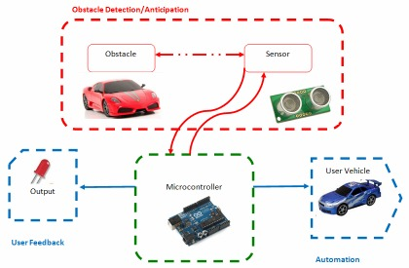

Figure 1: System Level Overview

The core component of the design is a microcontroller, as it is responsible for driving the sensors to gather data from the obstacles, and determine the safeness of the lane change. In addition, it will trigger the automation module in disabling the steering of the vehicle to prevent unsafe lane changes. The output will provide both qualitative and quantitative information to the driver regarding the situation. Details of each module can be found in the following section:

## Module-Level Description

The Design is split up into 3 distinct blocks:   
  
**Obstacle Detection/Anticipation**

The detection/anticipation module consists of the sensors, and a microcontroller. The SRF05 ultrasonic sensors will be mounted on the sides of the user’s vehicle to detect present and approaching obstacles in the blind spot (Appendix F). The microcontroller will signal the sensors to send an ultrasonic wave. Once the wave has been reflected by the obstacle, the sensor will provide the microcontroller with a pulse. The controller will convert these pulses to distance values, which can be used to establish the position and the relative speed of the obstacle (Appendix G). Ultimately, the microcontroller will establish the time left to perform a safe lane change. These values will be compared against a look-up table (Appendix H) to determine the safeness of the lane change. The microcontroller’s calculations will be represented on the output module.

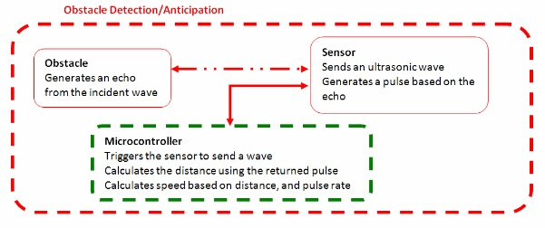

Figure 2: Obstacle Detection/Anticipation Module

**Output**  
The output module consists of two LEDs, and a display. It provides the user with feedback based on the microcontroller’s calculations. The LEDs blink at certain frequencies to warn users of varying levels of danger (Appendix H). The display directly outputs the relative speed of the obstacle, distance between the user vehicle and the obstacle, and most importantly, the calculated time left for a lane change.   
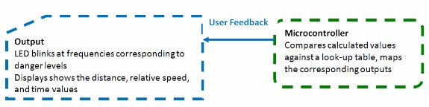

Figure 3: Output Module

**Automation**

The automation block is responsible for preventing users from colliding into the obstacle. If the obstacle’s speed and distance values correspond to the “Extremely unsafe” or worse conditions (Appendix H), the microcontroller will lock the steering of the vehicle on the side corresponding to the obstacle presence. This will prevent users from steering in the direction of the obstacle, and thus preventing a side collision.

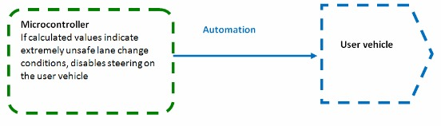

V

Figure 4: Automation Module

# Work Plan Work Breakdown Structure (WBS)

The following table outlines the tasks and the members responsible:

|  |  |  |  |  |
| --- | --- | --- | --- | --- |
| **Task Number** | **Task** | **Tanzim** | **Hani** | **Valikhan** |
| **I. Initial Research** | | | | |
| 1 | * Input Methods (Sensors) | R |  | A |
| 2 | * Output Methods (LED) |  |  | R |
| 3 | * Processing Methods (Arduino) | A | R |  |
| 4 | * Blind spot angles, sensor detection angles & ranges | R | A |  |
| **II. Obstacle Detection** | | | | |
| 5 | * Program the Arduino to retrieve input from the sensors | R | A |  |
| 6 | * Program the Arduino to set up output display |  | A | R |
| 7 | * Integrate the input and output components to provide user feedback according to the microcontroller’s calculations | R | A | A |
| 8 | * Install the completed obstacle detection module to a RC car | A | R | A |
| **III. Vehicle Anticipation** | | | | |
| 9 | * Design an algorithm to detect approaching vehicles and calculate their relative speed | R |  | A |
| 10 | * Refine safe distances and time constants to make lane changes based on testing |  | R |  |
| 11 | * Program the Arduino to provide feedback warning users of approaching obstacles | A |  | R |
| **IV. Automation** | | | | |
| 12 | * Achieve full control of the RC vehicle through the Arduino | A | R |  |
| 13 | * Program the Arduino to lock the steering of the user vehicle to prevent unsafe lane changes | A | R | A |

Table 3: Work Breakdown Structure

## 

## Financial Plan

The following table outlines the costs associated with the required components:

|  |  |  |  |  |  |
| --- | --- | --- | --- | --- | --- |
| **Item Description** | **Priority** | **Cost/per unit** | **Is it free?** | **Quantity (No. of hours)** | **Total Cost** |
| **Arduino-Uno Microcontroller Kit  a. Microcontroller  b. Motor  c. Manual**  **d. Small circuit components** | 1 | $82.00 | N | 1 | $82.00 |
| **SRF05 Ultrasound Sensors** | 2 | $45.00 | N | 2 | $90.00 |
| **LED Breakout Kit** | 3 | $0.60 | N | 1 | $2.00 |
| **LCD alphanumeric display** | 6 | $12.00 | n | 1 | $12.00 |
| **Software** | 4 | $0.00 | y | 1 | $0.00 |
| **RC cars:  a. 1 user RC car   b. 1 obstacle car** | 5 | $35.00  $22.50 | n | 2 | $57.50 |
|  |  |  |  |  |  |
| **Total contribution for 3 students** | N/A | N/A | N/A | 3 | $-243.50 |
| **Total contribution from supervisor** |  |  |  |  | $0.00 |
| **Net amount requested from Design Centre** | N/A | N/A | N/A | N/A | $300.00 |

Table 4: Financial Plan

Our design consists of several essential parts: microcontroller, input sensors, output sensors. Unavailability of any design elements mentioned above will cause a failure of the design. In case of lack of funds, our team could alternate parts to cheaper ones. However, this will lead to a lack of performance, as well as reduction of design reliability.

## Feasibility Assessment (Resources, Risks)

Skills and Resources  
  
The following skills will be needed in order to complete the design:

* Knowledge of C++ programming
* Knowledge of microcontrollers (software/hardware)
* Knowledge of RC Car operation (acceleration, control)
* Knowledge of the SRF05 sensors and their operation
* Knowledge of basic dynamics

The team knows how to code in C++ from previous programming courses. Knowledge of micro-controller hardware will be gained by looking at manuals, and specification sheets. Software knowledge can be gained by looking through open source code for other projects. The team already has the ability to understand and define calculations needed for relative speed, distance, and time allowed for lane changes. However, to convert these calculations to software algorithms will require further research. Further knowledge on vehicle dynamics may be required if problems arise from treating objects as particles. Knowledge of the SRF05 ultrasonic sensors has been obtained through research on the web, and looking at the device specifications. However, further knowledge on sonar technology may be required to troubleshoot issues regarding the sensors if they arise.

The following resources will be needed:

* Arduino Uno microcontroller kit (includes breadboard, small circuit components)
* SRF05 Ultrasound Sensors
* One RC car to be used as the user vehicle
* Multiple toy cars to be used as blind spot obstacles (BSO)
* Test Track to be used for road simulation
* LED lights and an LCD display are to be used for providing feedback

The mentioned resources can be easily obtained once the development of the project is initiated.

Risk Assessment

We have identified the following risks:

* There are various risks associated with the use of the SRF05 Sensors:
  + The distance calculations may be inaccurate due to higher than expected error. This will introduce error in all of the following calculations (relative speed, time allowed for lane change), thus hindering the basic and advanced functionalities of the design. One possible solution is to consider the sensor alternatives we have already researched.
  + The sensor may pick up undesired objects such as trees, road signs etc. We may need to design the test track to not include such components, and thus reducing the realistic value of the project. A solution would be to design algorithms to only identify vehicular obstacles.
  + The sensors may behave differently according to the obstacle’s build material, as well as weather and lighting conditions. We may need to narrow the testing conditions (test with only one type of obstacle under a single test environment not subject to stressful weather or light conditions) to account for this issue.
  + The SRF05 sensor will not always behave as expected, and there may be “dead zones”. Our solution to this risk is to add in a back-up sensor, which would fill in the dead zones of the SRF05. In addition, we need to create our algorithm in such a way that the two sets of sensors are able to interact without interfering with each other
* To accomplish automation module of the project, we may need to control steering of the RC car by sending signals to its antenna. Associated risks might be the interference of other signals with our control signal. One solution would be to use frequencies out of the range of standard electronics (cell phone, radio, etc.).
* To verify the obstacle anticipation module, we need to ensure constant speeds of 2 RC cars. However, this may be very difficult to implement. One solution could be to leave the user

# [8]References

[1] Transport Canada, “Canadian Motor Vehicle Traffic Collision Statistics: 2009”, Internet: <http://www.tc.gc.ca/eng/roadsafety/resources-researchstats-menu-847.htm>, Jun. 01, 2011 [Sep.11, 2011].   
  
[2] Unknown, “What Causes Car Accidents? “, Internet: <http://www.smartmotorist.com/traffic-and-safety-guideline/what-causes-car-accidents.html>, Apr. 13, 2008 [Sep. 05, 2011].

[3] Unknown. “Lane Change and Lane Departure Warning”. Internet: <http://www.bmw.com/com/en/newvehicles/5series/sedan_active_hybrid/2011/showroom/safety/lane_departure_warning.html#t=l>, Unknown date [Sep. 15, 2011].

## [4] [Emily Clark](http://www.gizmag.com/author/emily-clark/). “Active care safety features a top priority according to new research”. *Gizmag*. Available: <http://www.gizmag.com/go/8186/>, Oct. 16, 2007 [Sept 15, 2011].

[5] Unknown. “Blind Spot Information System (BLIS) with Cross-Traffic Alert”. Internet: <http://media.ford.com/images/10031/BLIS.pdf>, Jun. 7, 2011 [Sep. 15, 2011].

[6] Ministry of Transportation of Ontario, “A guide to oversize/overweight vehicles and loads in Ontario” Internet: <http://www.mto.gov.on.ca/english/trucks/oversize/guide.shtml>, [Oct. 10, 2011]

[7] Y. Kolesnikov. “Blind spot”. *Russian Bazaar.* 23(581). Available: <http://www.russian-bazaar.com/Article.aspx?ArticleID=10506>”, Jun. 13, 2007 [Sep. 20, 2011].

[8] Unknown. “SRF05 - Ultra-Sonic Ranger: Technical Specification”. Internet:<http://www.robot-electronics.co.uk/htm/srf05tech.htm>, [Jul. 25, 2011].

## Appendix A: Student – Supervisor Agreement Form

Our signatures below indicate that we have read and understood the following agreement, and that all parties will do their best to live up to the word as well as the spirit of it.

We agree to meet at least once every two weeks for at least half an hour to discuss progress, plans, and problems that have arisen. Before each meeting, the group will prepare a brief progress report that will form the basis for the discussions at the meeting.

If a meeting has to be cancelled by the supervisor, she/he should advise the group as early as possible. If a student cannot attend a meeting, she/he should advise members of the group as well as the supervisor as early as possible.

Both the supervisor and the students will:

Inform themselves of the course expectations and grading procedure.

The supervisor will:

Provide regular guidance, mentoring, and support for his/her design project group(s),

Take an active role in evaluating the work and performance of the students’ by completing the supervisor’s portion of the grading forms for each course deliverable expediently.

Return a photocopy of the completed grading evaluation forms to the appropriate section administrator in a timely fashion.

Be aware of the aims and processes of the course as outlined in the Supervisor’s Almanac.

We have read and understood this agreement. Date: ________________

Signature of supervisor: ______________________________________

Signature of student: _________________________________________

Signature of student: _________________________________________

Signature of student: _________________________________________

## 

## Appendix B: Draft B Evaluation Form

## Appendix C: Report Attribution Table

This table should be filled out to accurately reflect who contributed to each section of the report and what they contributed. Insert rows as needed. The original completed and signed form must be included in the hardcopies of the final Project Proposal draft.

|  |  |  |  |
| --- | --- | --- | --- |
| **Section** | **Student Initials** | | |
| 1.TM | 2. HH | 3. VK |
| Executive Summary | RD, MR |  | ET |
| Background and Motivation | RS, RD MR | RS | RS, ET |
| Project Goal | ET, MR | RS | RD |
| Functional Requirements | ET | RS | RD, MR |
| Constraints | ET | RS | RD, MR |
| Objectives | ET | RS | RD, MR |
| Validation and Acceptance Test | RS, ET, MR | RD, RS | RS |
| Possible Solutions and Design Alternative | ET, MR | RS, RD | RS |
| Assessment of Proposed Design | MR | RD | ET |
| System-Level Overview | RS, ET | RS, RD, MR |  |
| Module-Level Description | RS, RD | RS, MR |  |
| Work Breakdown Structure (WBS) | RD |  | MR |
| Financial Plan |  |  | RD, ET, MR |
| Skills and Resources | RD, MR |  | ET |
| Risk Assessment | RD |  | ET, MR |
| Appendix D: Statistics on Collisions and Casualties | RD | MR |  |
| Appendix E: Quantitative Measures for Technical Requirements | RS | MR | RD |
| Appendix F: Blind Spot Region |  | ET | RD, MR |
| Appendix G : Calculations Performed by the Microcontroller | ET |  | RD, MR |
| Appendix H: Classification of Danger Levels | RD | MR |  |
| Appendix I: Gantt Chart |  |  | RD, MR |
| All | FP | CM | FP |

Table 5: Report Attribution Table

**Abbreviation Codes:**

Fill in abbreviations for roles for each of the required content elements. You do not have to fill in every cell. The “**All**” row refers to the complete document and should indicate who was responsible for the final compilation and final read through of the completed document.

RS – responsible for research of information

RD – wrote the first draft

MR – responsible for major revision

ET – edited for grammar, spelling, and expression

OR – other

“All” row abbreviations:

FP – final read through of complete document for flow and consistency

CM – responsible for compiling the elements into the complete document

OR - other

If you put OR (other) in a cell please put it in as OR1, OR2, etc. Explain briefly below the role referred to:

OR1: enter brief description here

OR2: enter brief description here

**Signatures**

By signing below, you verify that you have read the attribution table and agree that it accurately reflects your contribution to this document.

|  |  |  |  |  |  |
| --- | --- | --- | --- | --- | --- |
| **Name** | Tanzim Mokammel | **Signature** |  | **Date:** |  |
| **Name** | Hani Hadidi | **Signature** |  | **Date:** |  |
| **Name** | Valikhan Kuparov | **Signature** |  | **Date:** |  |

## 

## Appendix D: Statistics on Collisions and Casualties

The following table has been extracted from [1], and it displays statistics on vehicle accidents in Canada from 1990-2009:

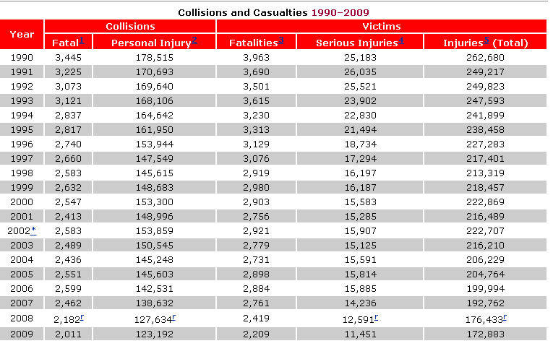

Table 6: StatsCan Statistics on Vehicle Accidents

The following graphs plot the boldly outlined statistics:

Figure 6: Fatal Collisions and Fatality Victims (1990-2009)

Figure 7: Collisions Resulting in Injury and Victims Injured (1990-2009)

## Appendix E: Technical Requirements of the Device

The following table outlines the technical requirements to be met by the device:

|  |  |
| --- | --- |
| **Technical Requirements** | **Quantity** |
| **Sensor’s frequency of acquisition** | 20 Hz |
| **Sensor’s range of acquisition and accuracy** | 3cm - 3 m, +-2.5% error |
| **Sensor’s angle of detection** | See figure below [8] |
| **Power** | 9 V (±2V) lithium-ion batteries |

Table 7: Device’s Technical Requirements

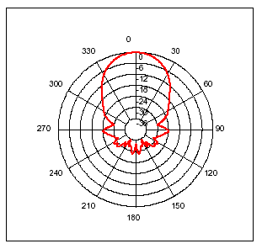

Figure 8: Sensor's Angles of Detection [8]

## Appendix F: Blind Spot Region.

The following figure illustrates angles associated with left and right blind spot areas for a typical mid sized sedan [7]. However, for the purpose of the design project, these values will be scaled down according to the chosen RC car’s sclaing factor defined on its specification sheet.

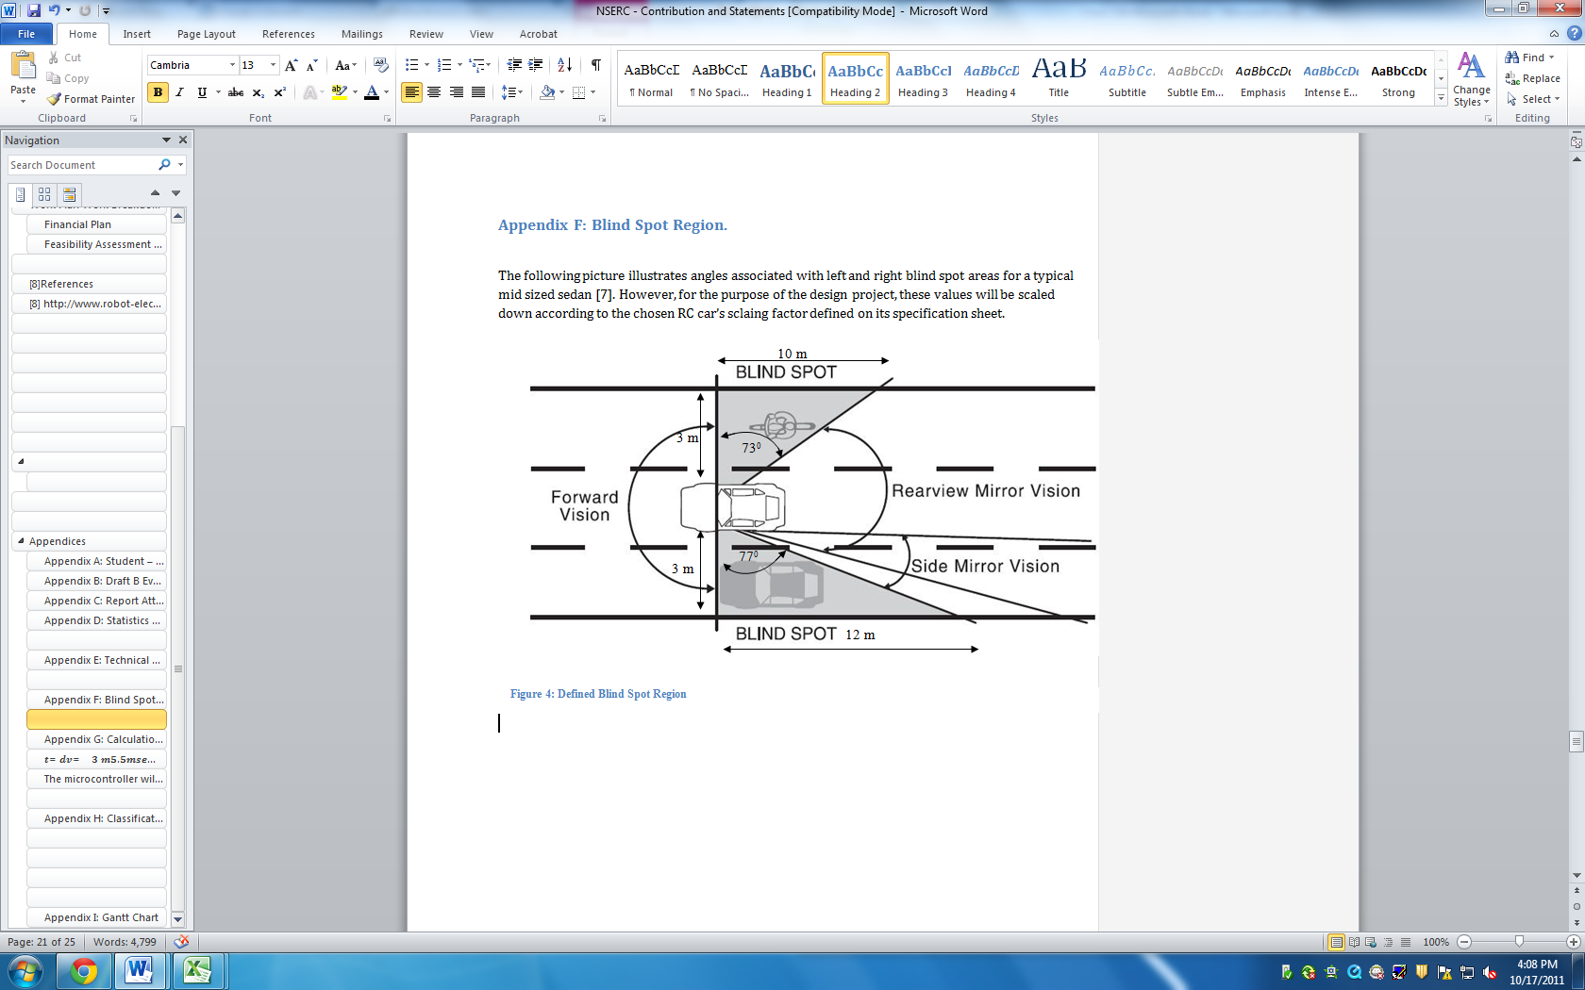

Figure 9: Defined Blind Spot Region

## Appendix G: Calculations Performed by Microcontroller

In this appendix, an example is used to demonstrate the calculations perfomed by the micorcontroller in determining the time left for an approaching obstacle to reach the blind spot of the user vehcile (critical time).

Figure 4 illustrates the situation on the road before user vehicle A starts a lane change. Initially, two cars are in Position 1 with speeds Va and Vb, respectively. At Position 1, the distance between the user vehicle (A) and obstacle (B) are equal to the distance (d): the detection range of sensor on the A. As B moves faster than the A, B takes critical time (t) to reach the blind spot of A. Position 2 illustrates this situation.

The process of finding the time required for a safe lane change is illustrated in Figure 5. A remains stationary, and B approaches with a known constant velocity V.

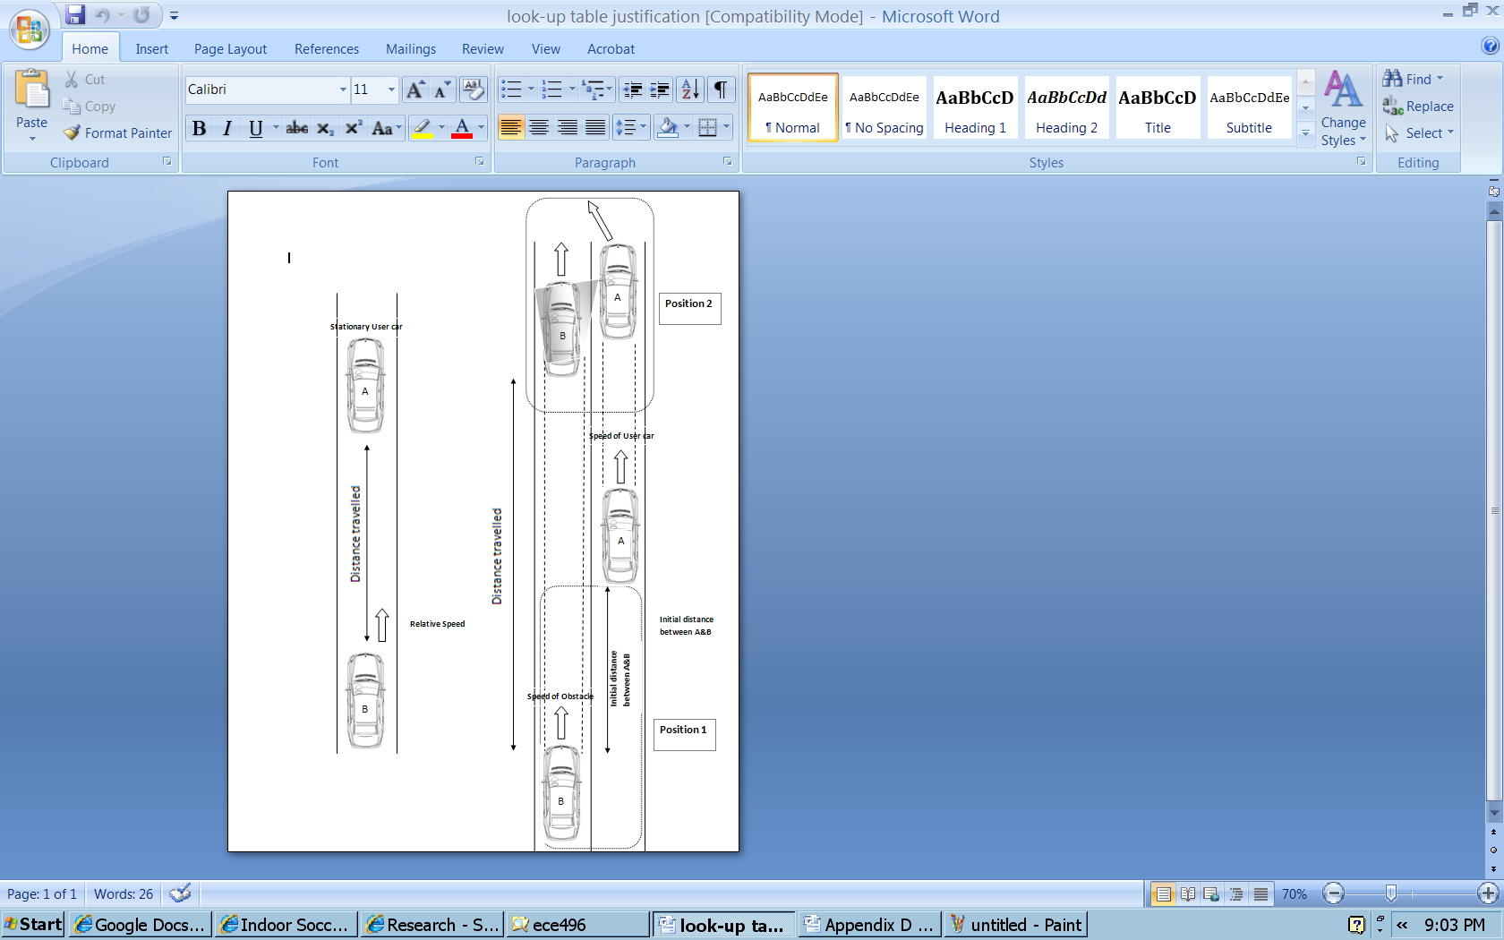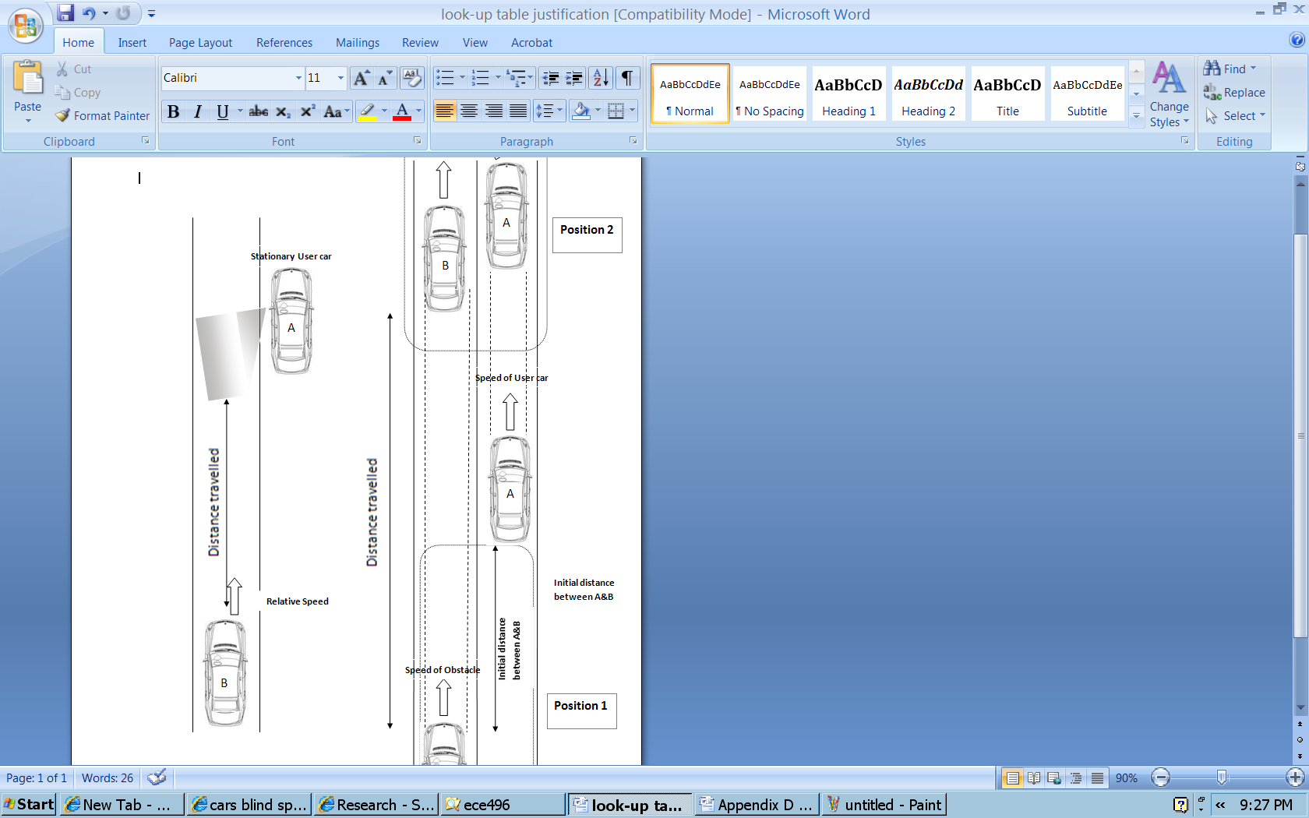For the sake of calculations, the following data is used outlining an extreme scenario based on actual vehicle speeds:

Figure 11: Considerations for Critical Time Calculations

Figure 10: Obstacle Approaching the User Vehicle’s Blind Spot

|  |  |  |
| --- | --- | --- |
| User vehicle (A) speed | 100 km/h | 28 m/s |
| Obstacle (B) speed | 200 km/h | 56 m/s |
| Relative speed b/w A and B | 100 km/h | 28 m/s |

Considering the limilations of the sensor (range, allowed trigger rate), the following table has been decided to be the the parameters for the most extreme case in the case of the remote controlled car. These values are used to calculate the critical time (t).

|  |  |  |
| --- | --- | --- |
| User vehicle (A) speed | 20 km/h | 5.5m/s |
| Obstacle (B) speed | 40 km/h | 11 m/s |
| Relative speed b/w A and B | 20 km/h | 5.5 m/s |
| Distance to be travelled by obstacle (range of detection) | 3 m |  |

Using numerical values in Table above, we are able to calculate critical time:

## The microcontroller will acquire the distance (d) from the sensors. The velocity (v) will be calculated with from the trigger rate of the sensors, and the rate of change in distance (d) values. Using these, the critical time (t) will be calculated as demonstrated above. Once the critical time (t) is found, it is to be compared against the look-up table defined in Appendix H.

## 

## Appendix H: Classification of Danger Levels

The following table is to be used by the microcontroller to compare calculated values and determine danger levels. The table also provides corresponding outputs, and cases where counter steer is required.

|  |  |  |  |  |
| --- | --- | --- | --- | --- |
| **LED Frequency (Hz)** | **Critical Time (s)** | **Classification** | **Description** | **Enable Counter Steer** |
| **0** | >15 | Safe | No obstacles present | N |
| **5** | 11-15 | Caution needed | Obstacle approaching | N |
| **20** | 6-11 | Unsafe | Obstacle approaching | N |
| **50** | 3-6 | Very unsafe | Obstacle approaching and near | N |
| **50** | 1-3 | Extremely unsafe | Obstacle very near | Y |
| **100** | 0 | Extremely dangerous | Obstacle already in blind spot | Y |

Table 8: Classification of Danger Levels

## 

## Appendix I: Gantt Chart

The following Gantt chart outlines the schedule to be followed by the team:

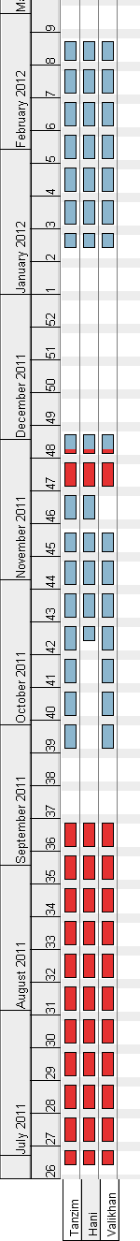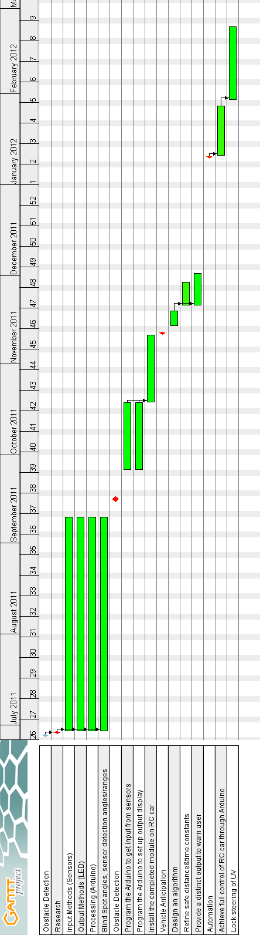

Figure 12: Gantt Chart